**Google Data Analytics**

**Foundations: Data, Data, Everywhere**

**Data Analysis Process:**

1. **Ask:** Define the problem and confirm stakeholder expectations
2. **Prepare:** Collect and store data for analysis
3. **Process:** Clean and transform data to ensure integrity
4. **Analyse:** Use data analysis tools to draw conclusions
5. **Share:** Interpret and communicate results to others to make data-driven decisions
6. **Act:** Put your insights to work in order to solve the original problem

**Analytical skills**

Qualities and characteristics associated with solving problems using facts

1. **Curiosity**: Wanting to learn something, seeks experiences and challenges
2. ﻿﻿﻿**Understanding context:** The condition in which something exists or happens
3. **﻿﻿﻿Having a technical mindset:** The ability to break things down into smaller steps or pieces and work with them in an orderly and logical way
4. ﻿﻿﻿**Data design:** How you organise information
5. **﻿﻿﻿Data strategy:** The management of the people, processes and tools used in data analysis

**Data Life Cycle:**

1. **Plan:** Decide what kind of data is needed, how it will be managed, and who will be responsible for it.
2. **Capture:** Collect or bring in data from a variety of different sources.
3. **Manage:** Care for and maintain the data. This includes determining how and where it is stored and the tools used to do so.
4. **Analyse:** Use the data to solve problems, make decisions, and support business goals.
5. **Archive:** Keep relevant data stored for long-term and future reference.
6. **Destroy:** Remove data from storage and delete any shared copies of the data.

**References** : Harvard Business School (HBS) Data Life cycle (https://online.hbs.edu/blog/post/data-life-cycle)

**Tools used by Data Analysts:**

1. **Spreadsheets** : Microsoft Excel and Google Sheets

* Collect, store, organise, and sort information
* Identify patterns and piece the data together in a way that works for each specific data project
* Create excellent data visualisations, like graphs and charts

2. **Databases and Query languages:** MySQL, Microsoft SQL Server, and BigQuery

* Allow analysts to isolate specific information from a database(s)
* Make it easier for you to learn and understand the requests made to databases
* Allow analysts to select, create, add, or download data from a database for analysis

3. **Visualisation tools:**

- **Tableau**'s simple drag-and-drop feature lets users create interactive graphs in dashboards and worksheets

* **Looker** communicates directly with a database, allowing you to connect your data right to the visual tool you choose

**Different Job titles:**

* **Business analyst** — analyzes data to help businesses improve processes, products, or services
* **Data analytics consultant** — analyzes the systems and models for using data
* **Data engineer** — prepares and integrates data from different sources for analytical use
* **Data scientist** — uses expert skills in technology and social science to find trends through data analysis
* **Data specialist** — organizes or converts data for use in databases or software systems
* **Operations analyst** — analyzes data to assess the performance of business operations and workflows

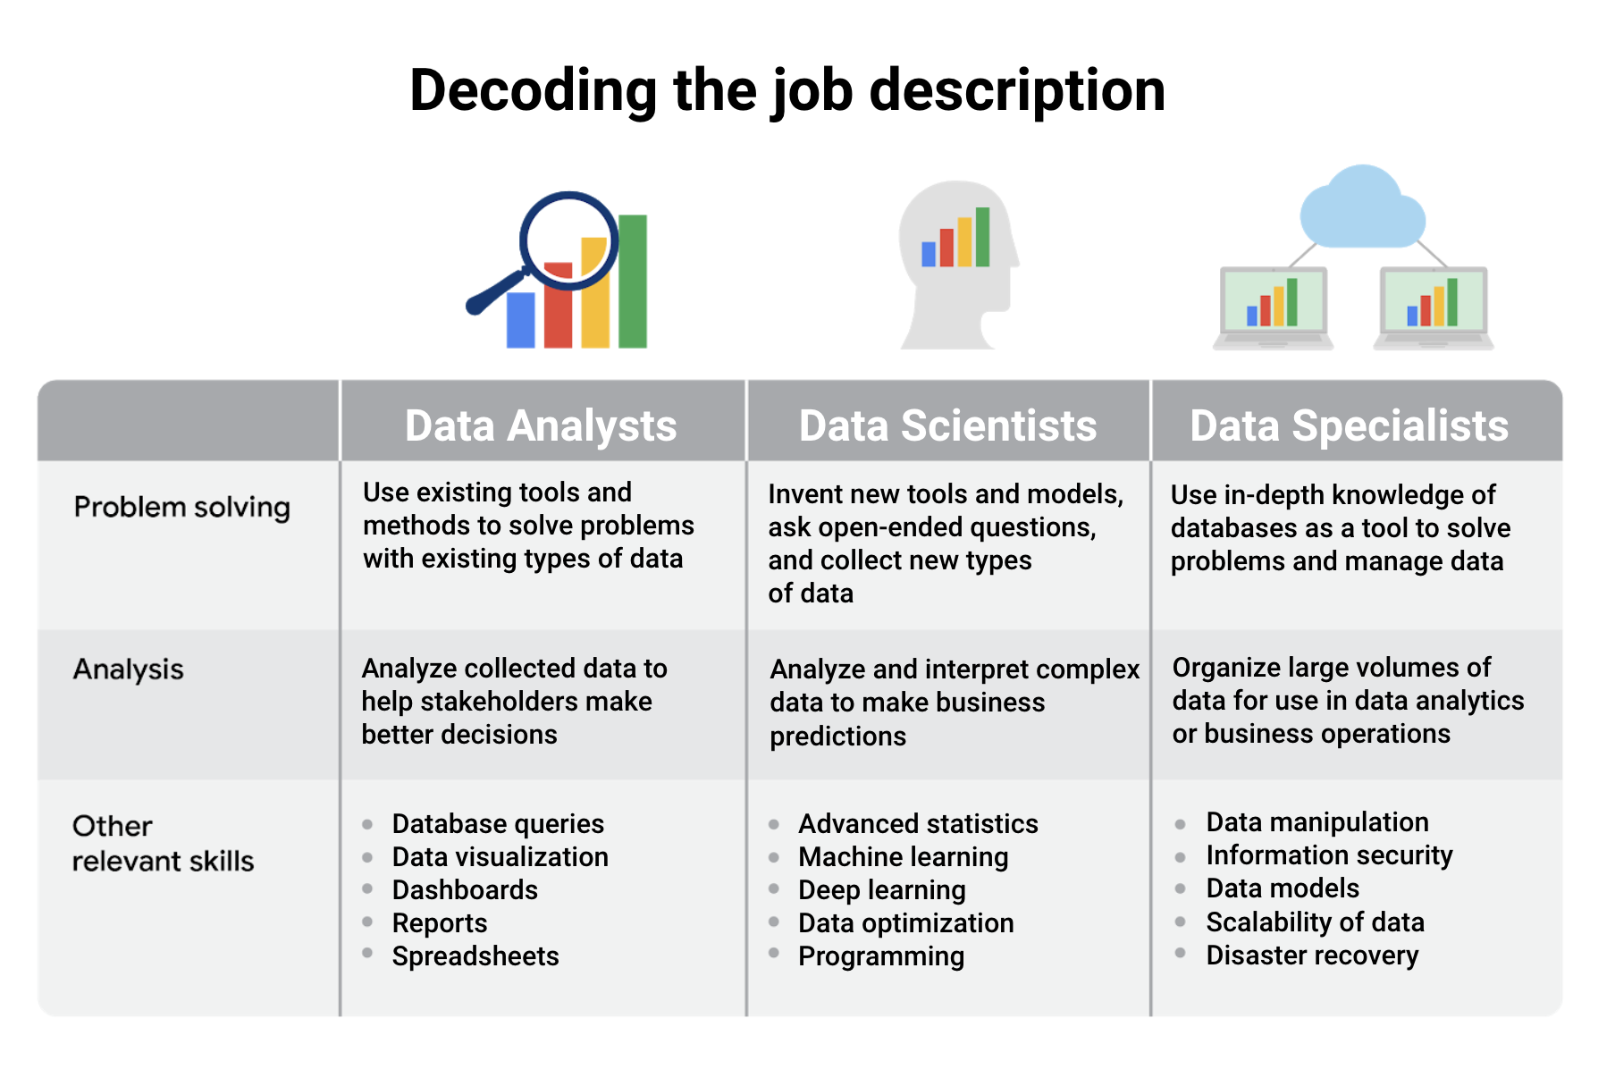

**Other industry-specific specialist positions:**

* **Marketing analyst** — analyses market conditions to assess the potential sales of products and services
* **HR/payroll analyst** — analyses payroll data for inefficiencies and errors
* **Financial analyst** — analyzes financial status by collecting, monitoring, and reviewing data
* **Risk analyst** — analyzes financial documents, economic conditions, and client data to help companies determine the level of risk involved in making a particular business decision
* **Healthcare analyst** — analyzes medical data to improve the business aspect of hospitals and medical facilities